***Employment Structures and Patterns***

*Development Quaternary Industry*

*Economic Industrial Revolution*

*Employment Secondary Industry*

*Formal sector Self-employed*

*Gender Source*

*North-South Divide Tax*

*Primary Industry Tertiary Industry*

*Trade Aid & Debt Quality of Life*

**Development Word Mat**

**Case Studies**

|  |  |  |  |
| --- | --- | --- | --- |
| MEDC | | LEDC | |
| Place | **Country** | **Place** | **Country** |
|  |  |  |  |
|  |  |  |  |
|  |  |  |  |
|  |  |  |  |
|  |  |  |  |
|  |  |  |  |

**The Brandt Line**

***Development: Trade Aid & Debt***

*Capitalism*

*Communism*

*Cultural Development*

*European Economic Community (EEC)*

*European Union (EU)*

*The Euro Currency*

*Globalisation*

*Gross National Product (GNP)*

*Human Development Index (HDI)*

*International Monetary Fund (IMF)*

*Intermediate Aid*

*Non-governmental Organisation (NGO)*

*Protectionism Poverty*

*Quota Tiger Economies*

*Third World Tariff*

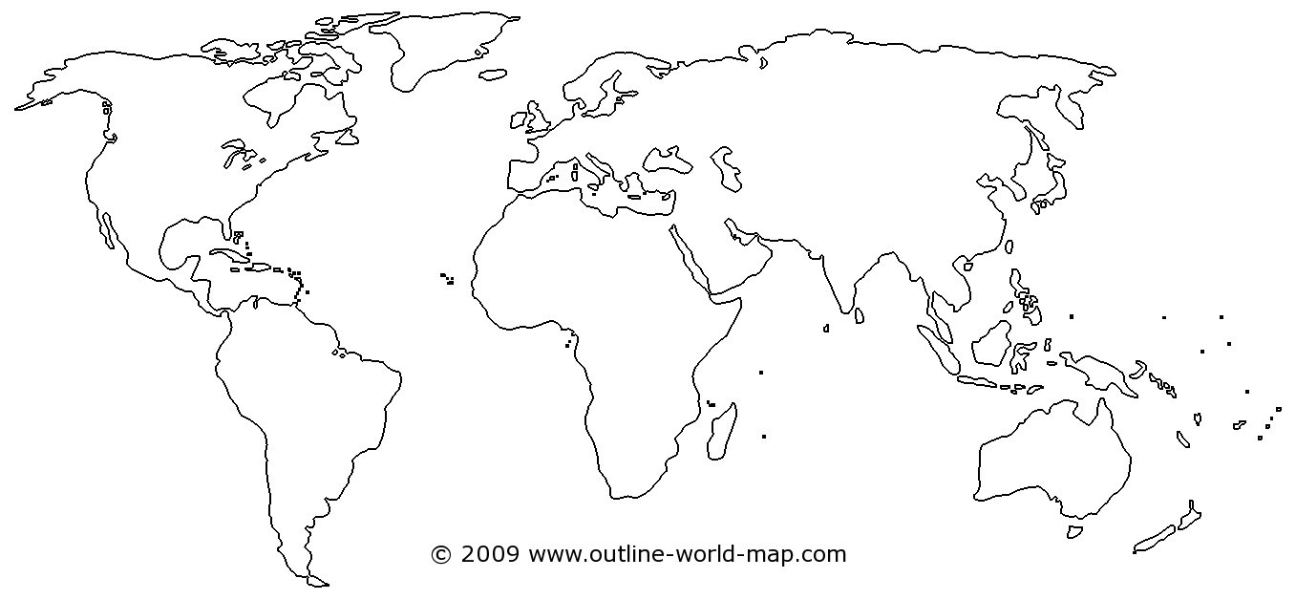

|  |  |
| --- | --- |
| Measures of Development | |
| Human Development Index | HDI |
| Gross National Product | GNP |
| Gross Domestic Product | GDP |
| Per capita means per person | |

**Quality of Life Indicators**

|  |  |
| --- | --- |
| Life Expectancy | Car ownership |
| Adult Literacy Rate | **% emp Primary** |
| People per Doctor | **% emp Secondary** |
| Access to sanitation | **% emp Tertiary** |
| Access to safe water | **% emp Quaternary** |
| Infant mortality rate | **Pop growth rate** |
| Literacy rates | **% pop in urban** |
| Energy use |  |

C:\Program Files (x86)\Microsoft Office\MEDIA\CAGCAT10\j0222021.wmf